SOCIAL MEDIA REACH ANALYSIS
- View all records
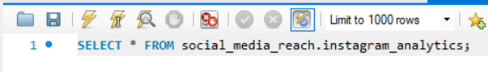
Output:
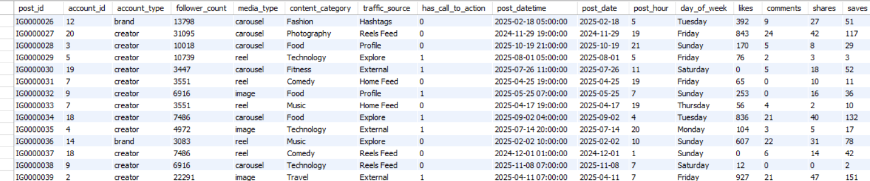
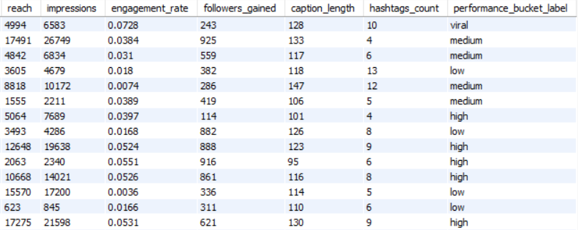
- Count total posts
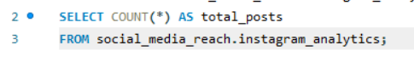
Output:
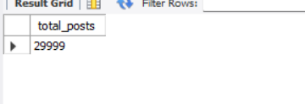
- Calculate average engagement rate
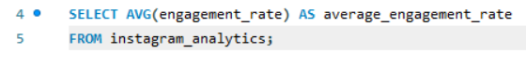
Output:
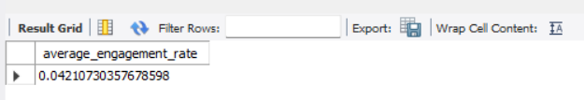
- Find total reach
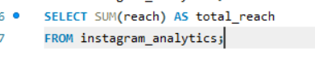
Output:

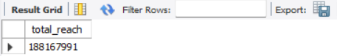
- Find total impressions
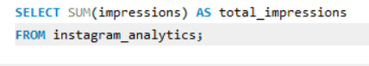
Output:
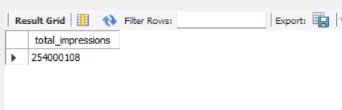
- Display top 10 posts with highest likes
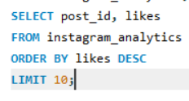
Output:
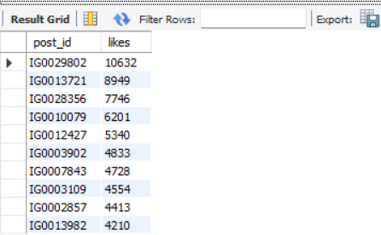
- Display top 10 posts with highest engagement rate
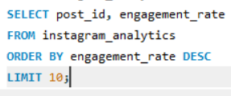
Output:

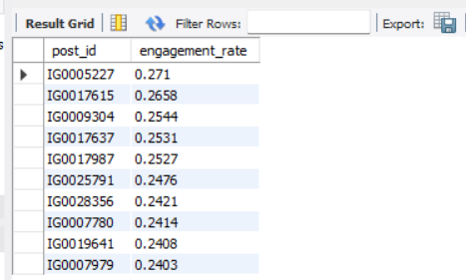
- Average likes by media type
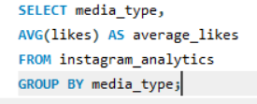
Output:
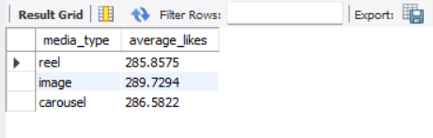
- Average engagement by day of the week
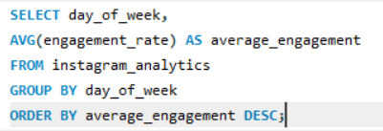
Output:
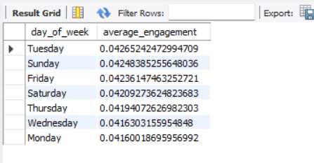
- Average reach by media type
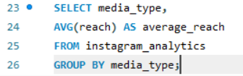
Output:
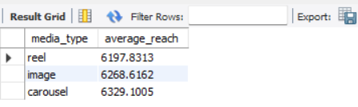
- Total followers gained by account type
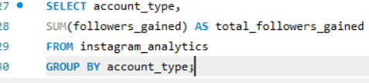
Output:

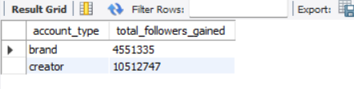
- Compare engagement with and without Call-To-Action
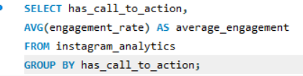
Output:
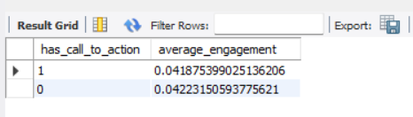
- Find top 10 posts by total engagement
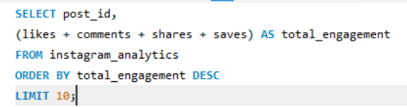
Output:
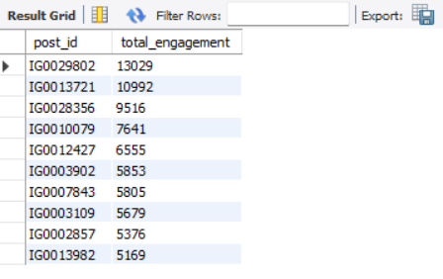
- Rank posts based on engagement rate
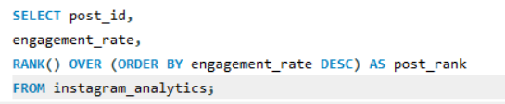
Output:

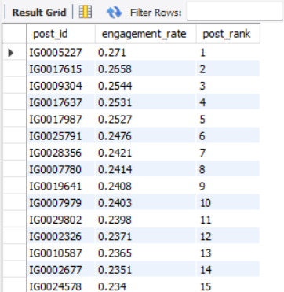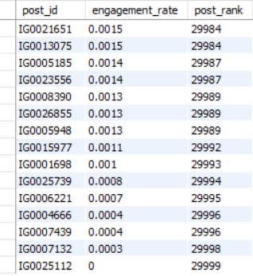
- Find the best-performing content category
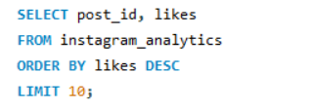
Output:
